

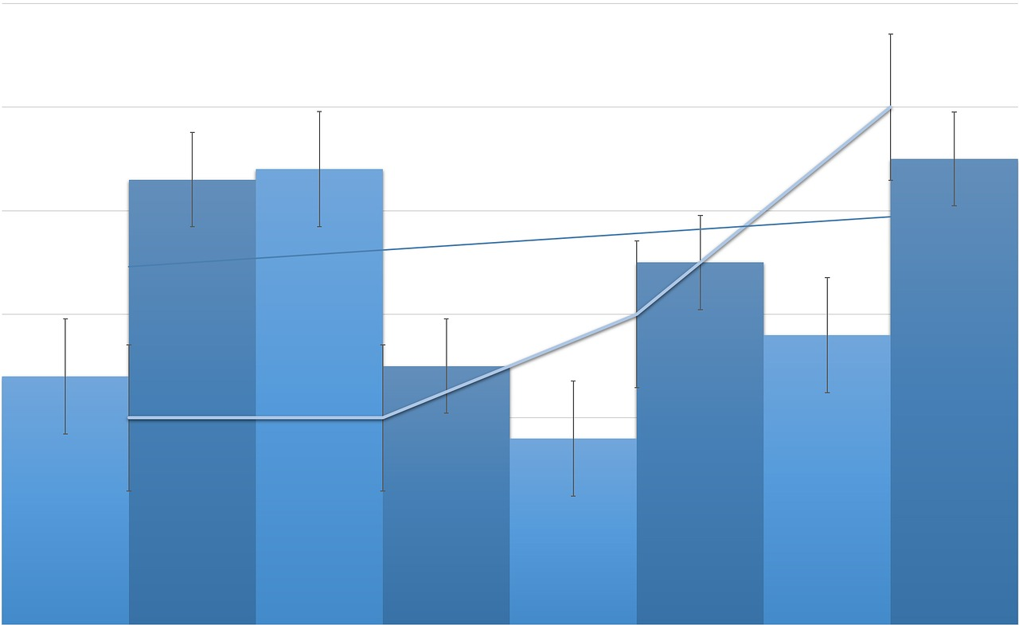

Prepared By: ________________________________  
Date: ______________________________________

Signature: __________________________________

Marketing Analysis Report

**Industry:**

* Have you established your business in food industry?
* What are the major trends in food industry?
* Is food industry in growth phase?

**Target Customers:**

* Who are your target customers? (Individuals, small businesses)
* What about demographic makeup of target customers? (age, sex, profession etc)

**Market Size analysis:**

* Physical area of your market (for example 20-mile radius)
* Numbers of potential customers in your area?

**Competition:**

* How long you have been in your business?
* How much business you have done?
* Your strengths and weaknesses?
* Why customers prefer you instead of your competitors

**Elements of Market Analysis**

Market Analysis of Restaurant Business